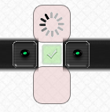Bug Report:

1. When removing glass while it is processing/animating on the GUI, the animation image stays frozen on the GUI after the glass is removed, but when another piece of glass begins to animate/process there again, the image gets reset.

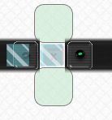2. On the green conveyor family, I broke the conveyor at a time where a piece of glass was *almost* about to hit the popUp, but stopped it just short of doing so. When attempting to restart the conveyor, it would not do so, even when sending a piece of glass to the entry sensor. It requires tricky timing, but this bug can be replicated.

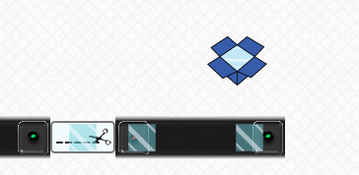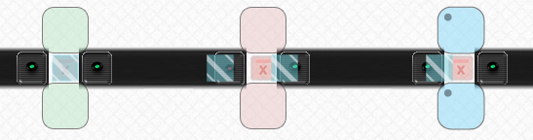3. On the green conveyor family, the popUp was broken, and the glasses were piled up. When un-braking the popUp, the result above occurred where a piece of glass was stuck on the green popUp. This bug can be replicated. The green popUp needs to be broken before the test glasses arrive to see this bug.

4. A piece of glass can get permanently stuck on an online machine by first breaking it so a piece of glass gets on it, then breaking and un-breaking in quick succession to get the result seen at the right. The bug was replicated multiple times just to make sure that this is what really caused it. The assumption is that all online machines fall prey to this problem.